ECE485 Computer Architecture

Lesson 31 Worksheet

Assume a 4 processor system with the cache coherence scheme on the reverse side. Processors P1, P2, and P4 have shared access to block A, and P3 has shared access to block B. The following events happen in sequence.

- Processor P1 needs to write to block A.

What message is placed on the bus?

What state does P1’s block status go to?

What state does P2’s block status go to?

- P2 needs to read from block A.

What message is placed on the bus?

What state does P1’s block status go to?

What state does P2’s block status go to?

What state does P4’s block status go to?

- P1 needs to read from block B, which replaces block A due to the block replacement strategy of the cache.

What message is placed on the bus?

What state does P1’s block status go to?

What state does P3’s block status go to?

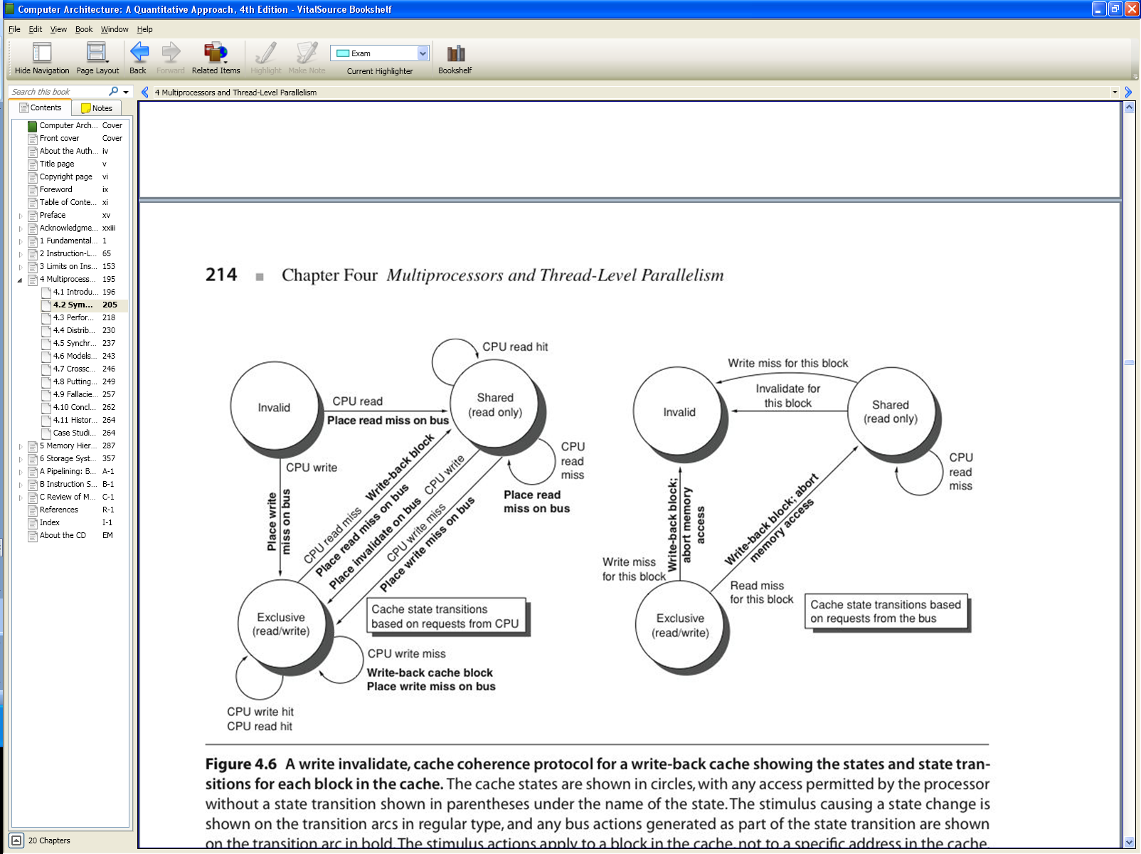

© 2003 Elsevier Science (USA). All rights reserved.

